SUBJECT LINE: F2D: Make Road safety a priority! Book your road safety workshop today!

auburn.hs@education.vic.gov.au

ella.price@education.vic.gov.au

Dear Ella Price and Auburn High School,

**Our F2D Workshop is back again! The last time you booked was 29 March 2022, don't forget the importance of road safety within your community.**

I am reaching out regarding our F2D Year 11 Workshop.  
  
The Fit to Drive Foundation is one of Victoria’s leading road safety education providers for young people.

We pride ourselves on delivering relevant, informative, and interactive workshops with the support of key partners including Victoria Police and Fire Rescue Victoria.

**The F2D Year 11 Workshop is Fit to Drive’s half-day incursion for students in Year 11 or equivalent cohorts (including VCAL students or those approximately 16-17 years old).**

A flyer for the F2D Year 11 Workshop has been attached for your perusal.

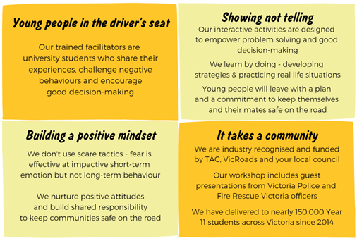

The cost to your school is only **$300 + GST**, provided we can secure funding from your Local Government.

We have received funding in your local area by Boroondara City Council in the past.

As our workshops are in high demand and booking up quickly, we thought we would prioritize contacting your school as you have previously engaged in 3 workshops. Your last workshop was 29 March 2022.

Don’t miss out on this opportunity to bring crucial road safety education to your students.

# TO MAKE A BOOKING:

Fill out the booking form on our website: [Click here](https://f2d.oxil.io/workshops/f-2-d-year-11-workshop/4/register)

Alternatively, reply to this email with the following details and I can book the workshop for you:

* What is your school’s name?
* What is your school’s Local Government Area (local council)?
* How many students are you looking to book the workshop for?
* What are your preferred dates for the workshop? (2-3 dates)
* Please include the following school times: start of school, start and end of recess, and start of lunchtime.

If you need more information on the suitability of the program for your students, please don’t hesitate to get in touch.

We’re happy to work with you in delivering the message of road safety to all young road users with their specific needs in mind.

I look forward to hearing from you. Please contact me on 0420 588 629 if you require any further information.